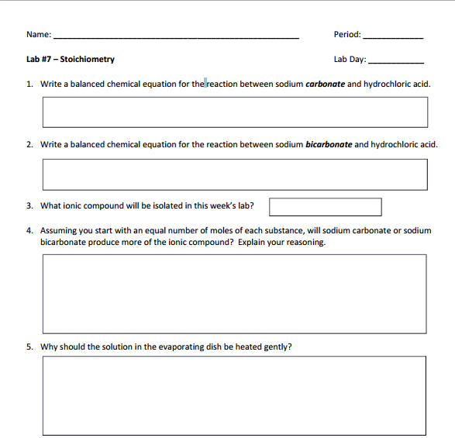

B2

8

Jonathan Quang

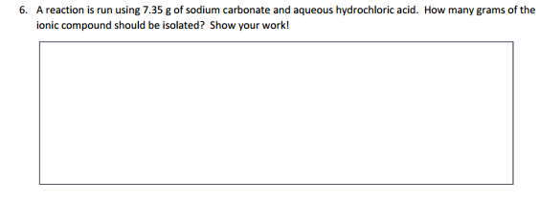

(7.35 g Na2CO3)()()()=5.056923494...g HCl  
Na2CO3 is the limiting reactant.

(7.35 g Na2CO3)()()()=8.10569....g NaCl

About 8.11 g of NaCl should be isolated.

The solution in the evaporating dish should be heated gently to let the water evaporate, leaving the salt in the dish.

Sodium carbonate will produce more NaCl because one mole of sodium carbonate will react with 2 moles of HCl to create 2 moles of NaCl where as one mole of sodium bicarbonate only reacts with 1 mole of HCl, creating only one mole of NaCl.

NaCl

NaHCO3 +HCL → NaCl + CO2 + H2O

Na2CO3 + 2HCl→ 2NaCl + CO2+H2O